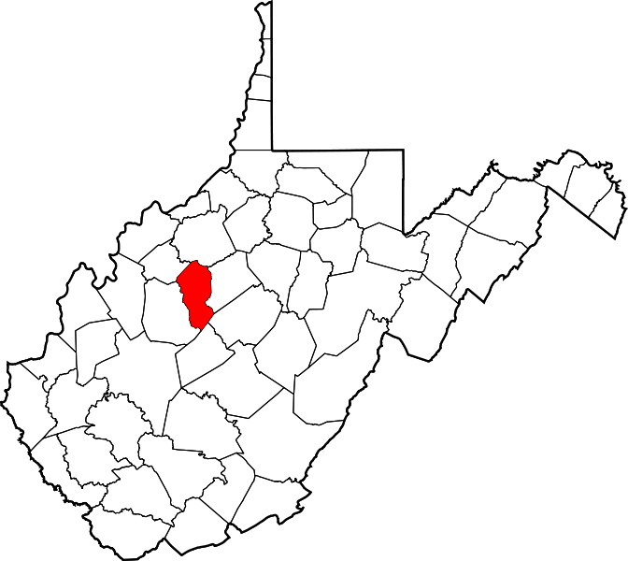
Calhoun County

Resource Guide
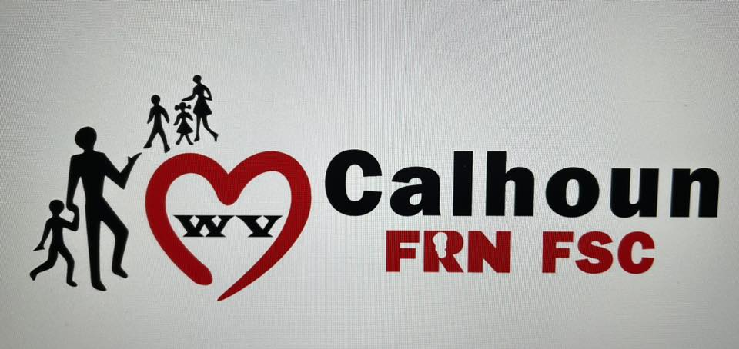WHO WE ARE
The Calhoun County Family Resource Network (FRN FSC) is a local coalition working to improve services for families and children in Calhoun County. The Calhoun County Family Resource Network works to assess community needs, develop local plans, promote changes, evaluate results, and assist agencies in improving the service delivery system. Calhoun Family Resource Network received its Non-profit status in September 2000.
WHAT WE DO
FRN has a wide and varied scope of work and often chose to focus efforts on the issues most pressing and relevant at the time. FRNs do not provide direct services, but rather work collaboratively with partner agencies to implement and support new or existing programs or projects. Additionally, FRN is often involved in assessing, planning, and coordinating efforts related to resources or services in the community. (See Page 11 for more information)
Important Dates
- Community Baby Shower – 1st Friday in November
- Christmas Express (sign ups – October) give-a-way (Week before Thanksgiving)

NOTES:

Emergency Numbers:

Ambulance 911
-Ambulance Garage 304-354-9244
Fire Department 911
-Calhoun Fire Department Arnoldsburg Garage 304-655-8974
-Calhoun Fire Department Grantsville Garage 304-354-6566
-Calhoun Fire Department Upper West Fork Garage 304-655-7491
Director of Emergency Services 304-354-9271
Calhoun County Sheriff’s Department 304-354-6333
Grantsville City Police Department 304-354-6334
State Police (Cell Phone) 77
Calhoun D.A.R.T (Domestic Violence) 304-354-9254
Poison Control Center 1-800-222-1222
Oil & Toxic Chemical Spills 1-800-642-3074
Child Protective Services Centralized Intake 1-800-352-6513
National Suicide Prevention Lifeline 988

**If you are unable to reach any of these emergency numbers CALL 911 if it is an emergency or 304-354-9271 for non-emergencies and dispatch will assist you.

WV 2-1-1
Every hour of every day, someone in West Virginia needs essential services- from finding substance abuse assistance to securing adequate care for a child or aging parents. Faced with a dramatic increase in the number of agencies and help lines, people often don’t know where to turn. In many cases, people often don’t know where to start. While services that are offered though 2-1-1 vary from community to community, 2-1-1 provides callers with information and referrals to human services for every day needs and in times of crisis.
Dial: 211 Website: http://www.wv211.org

Know before you go
West Virginia 511 is a Traveler Information System providing free, real-time traffic information, including congestion, crashes, construction, lane closures, road conditions and sever weather information on all of West Virginias interstates and other major highways.
Dial: 511 Website: http://www.wv511.org

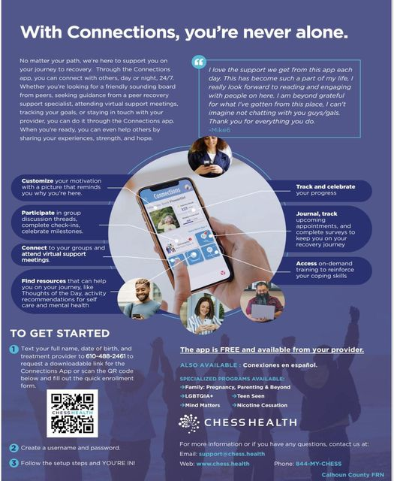

Animal Services
Cain’s Veterinary Clinic
304-354-6161
7519 W. Little Kanawha Hwy, Big Bend, WV 26136
Welfare of Animals Group (WAG)
304-354-6363
Reduced cost Cat & Dog Spay/Neuter Available
WAG can assist low-income Calhoun County homes with spaying and neutering of pets.
For more information or to make an appointment please call 304-354-6363

Crisis and Substance Abuse Services
Crisis Text line 24/7 support
Text HOME to 741741
Help 4 WV
844-435-7498
Mental Health Crisis Line 24/7
800-632-5449
National Suicide Prevention Hotline
800-273-8255
Options for deaf and hard of hearing
800-799-4889
Westbrook Crisis Lines
304-485-1725
800-579-5844
Dental services

Minnie Hamilton Health System- Grantsville
186 Hospital Dr. Grantsville, WV 26147
304-354-5999
MHHS Dental Clinic offers dental services for the whole family. Our practice is committed to providing exceptional care that addresses both your short- and long-term oral health needs. We offer general dental services including preventive and oral hygiene care, restorative treatment, oral surgery, dentures & partial dentures, crown and bridge, periodontics (treatment of gum disease) and root canal therapy. Many of our services are covered by the sliding fee program.

Education Service Providers
Anoldsburg Elementary School
90 Spring Run Road
Arnoldsburg, WV 25234
Telephone 304-655-8616
Calhoun County School Central Office
540 Alan B Mollohan Dr.
Mt. Zion, WV 26151
304-354-7011
Calhoun-Gilmer Career Center
5260 East Little Kanawha HWY Grantsville, West Virginia 26147
(304) 354-6151
Calhoun County Middle High School
50 Underwood Circle, Mt. Zion, WV 26151
304-354-6148
Pleasant Hill Elementary School
3254 N. Calhoun Hwy
Grantsville, WV 26147
304-354-6022
Little Kanawha Valley Christian School
6377 West Little Kanawha Highway, Big Bend, WV 26136
(304) 354-6436
Save the Children
304-655-8616 ext. 124
Save the Children provides early childhood education services to children birth to five years of age, education services to their parents. The program is designed to assist children with early language development, social and emotional development, and equip parents with the skills and knowledge to successfully support their child’s growth. The program is open to all families in the Calhoun County School District who has children ages 0-5. This service is provided at no charge.

Employment Service Providers
Career Connections
bdye@wdbmov.com
Workforce Development Board Mid-Ohio Valley-Workforce Innovation and Opportunity Act (WIAO)
YOUTH SERVICES: Career Connections: Services individuals ages 16-24. Services include basic job skills,
education assistance, paid work experience/on-the-job training, driver’s license preparation,
transportation assistance, and other individualized training and services. Must meet eligibility
requirements.
304-917-6143
ADULT SERVICES: Adult/Dislocated Worker: Assistance with tuition for in demand occupations,
apprenticeships and on-the-job training, job search, resume writing. Must meet eligibility requirements.
304-927-1909

Hospitals
Minnie Hamilton Health System
186 Hospital Dr. Grantsville, WV 26147
304-354-9244
www.mhhs.healthcare
Minnie Hamilton Health System is in the heart of West Virginia. At our rural hospital you will find professionals from diverse backgrounds working together to provide a comprehensive range of health care services. Services offered: Acute Care services, Long term care, Emergency room, Clinic services, and Pediatric services, dental services, cardiopulmonary, respiratory therapy, physical therapy, occupational and speech therapy, radiology, laboratory services, social services, infusion therapy, outreach and education services, and school based health centers.
Minnie Hamilton Health Services also provides assistance with medical cost with a sliding fee program. The sliding fee program reduces the cost of clinic office visits, laboratory and limited radiology and respiratory services. To qualify you must meet federal income guidelines, be ineligible for Medicaid and your insurance or Medicare must have a deductible or copay.

Library
Calhoun County Public Library
250 Mill Street
P.O. Box 918
Grantsville, WV 26147
304-354-6300
Hours:
Monday, Wednesday, Friday 8:00am - 3:00pm
Tuesday and Thursday 10:00am- 6:30pm.
Imagination Library
304-354-6300
www.imaginationlibrary.wv.gov
Dolly Parton’s Imagination Library serves children 0-5 years of age. They will receive, through the mail, a free book each month until their 5th birthday.
Local Courthouse
Calhoun County Circuit Clerk
Calhoun County Courthouse
P.O. Box 266
363 Main Street, Suite 205
Grantsville, WV 26147-0266
304-354-6910
Fax: 304-354-6173
Calhoun County Family Court
P.O. Box 327
378 Main Street
Grantsville, WV 26147
304-354-9277
Fax: 304-354-9291
Magistrate Lora Davis-Mace
Calhoun County Courthouse
P.O. Box 397
363 Main Street, Suite 104
Grantsville, WV 26147
304-354-6844

Local Courthouse Continued
Magistrate Richard G. Postalwait
Calhoun County Courthouse
P.O. Box 186
363 Main Street, Suite 105
Grantsville, WV 26147
304-354-6651
Calhoun County Clerk
P.O. Box 186
363 Main Street, Suite 103
Grantsville, WV 26147
304-354-6698
Fax: 304-354-9041
Probation Office (for both Roane and Calhoun Counties)
Alisha Lawson
304-354-7066
Main Street, Second Floor
Grantsville WV 26147
Nutrition Service Providers
First Baptist Food Pantry
1500 E. Little Kanawha Highway (RT. 5)
Grantsville, WV 26147
The pantry is open two days a week: Tuesday and Thursday from 11-1. Need more information call 304-354-6130.
Calhoun FRN FSC
364 Main Street
Grantsville WV 26147
304-354-7177
We are open Monday – Thursday from 8:30-2:30. We offer a weekly choice menu. Families can receive a pantry (1) time per week.
We also offer CSFP Senior Food Boxes (income based) and must 65 years or older.
Calhoun Community Resource
258 Court Street
Grantsville WV 26147
Emergency food assistance - based on income. Please call 304-354-9265

Nutrition Service Providers Continued
WV WIC-Calhoun
Mill Street
Grantsville WV 26147
304-354-6898
Office Hours: 8:00-4:00 Monday through Friday, with Clinic held every Wednesday
WIC has been improving healthy pregnancies and preparing kids to learn for 40 years. The program provides nutrition counseling; breast feeding support and food assistance to help you and your family live a healthy life. Some of the food provided through WIC: milk, cereal, cheese, peanut butter, eggs, juice, infant formula, fruits and vegetables, whole grains and baby foods.
Optical Service Provider
Calhoun Eye Clinic
256 Court St, Grantsville, WV 26147
(304) 354-7505
Pharmacies
J&B Drugstore
352 Main Street
Grantsville, WV 26147
304-354-7737
Walgreens
337 Main Street
Grantsville, WV 26147
304-354-9232
Road & Highway Maintenance

District three Department of Highway
624 Depot Street
Parkersburg, WV 26101
304-420-4595

Senior Citizen Service Providers
Calhoun County Committee on Aging
105 Market Street
P.O. Box 619
Grantsville, WV 26147
304-354-7017
The Calhoun County Committee On Aging, Inc., provides a wide variety of services and programs to our senior citizens and to our community, including but not limited to: Congregate Meals in the Grantsville Center Dining Hall, Transportation via Our Buses and/or Individual Pick-Up, In-Home Care Services (With 34 Personal Care Providers), "Meals On Wheels" via Our Two "Hot Delivery" Vehicles, "Family Alzheimer's In-Home Respite" Services (FAIR), Provision of Services Under West Virginia's, "Lighthouse" and "LIFE" Programs, "At Risk and Frail Elderly" Services.
Social Services
Calhoun FRN FSC
364 Main Street
PO Box 620
Grantsville, WV 26147
304-354-7177
calhounfrn@gmail.com
- Food Pantry
- CSFP (Senior Boxes)
- FSC Services – help families with children with basic needs.
- Healthy Grandfamilies
- Play groups
- Earn N Learn
- Recovery Meetings (Monday zoom 7pm, Biblical Based Tuesday at 2:30, Friday 1pm
Community Resources Inc.
PO Box 309, 258 Court Street
Grantsville WV 26147
304-354-9265
The CRI provides emergency services (food, utility termination, hygiene), weatherization, 1st Energy applications. ECIP (Energy Crisis Intervention Program, VITA (Volunteer Income Tax Assistance) Free for low income by appointment only beginning in January, Budgeting, Financial Literacy Courses, Work Force, and book bags.

Calhoun County DHHR
P.O. Box 280
85 Industrial Park Road
Grantsville WV 26147
304-354-6118
The Bureau for Children and Families provides an accessible, integrated, comprehensive quality service system for West Virginia's children, families, and adults to help them achieve maximum potential and improve their quality of life. Some of the services offered: Supplemental Nutrition Assistance Program-SNAP, Medicaid or Chip, Medicare Premium Assistance Program (Helps with paying your monthly Medicare Premium, WV Works, LIEAP, and School Clothing Allowance.
Calhoun Domestic Violence (DART)
304-354-9254
Court Street (Old jail building)
Grantsville WV 26147
800-794-2335
- Personalized Safety Plans
- Protection Orders
- Shelter support
- Individual Counseling
- Advocacy
- Sexual Assault Response Advocate
- Community Education
- Crisis Intervention
- Information & Referral
WVU Extension Service – Calhoun County
363 Main Street, Suite 403
P.O. Box 680
Grantsville, WV 26147

Jamie Mullins, 4-H Youth Development Jamie.Mullilns@mail.wvu.edu
Daisy Bailey, Agriculture & Natural Resource Daisy.Fryman@mail.wvu.edu
CalhounCountyExtension@mail.wvu.edu

Contact Telephone Number: (304)354-6332
Web page: https://extension.wvu.edu/calhoun

